Initial Project Report : November 18 th 2015
Team Members: Gilead Baggio,Sriram vijay
Company: Gramener Technologies
Project Title: Data Analysis (Phase 1)

Project Overview:

The aim of our project is to analyse the given data and visualize the data.The data is about the students performance in Mathematics exams conducted across India.The mathematics test conducted for the Class VIII students, consisted of two test booklets; each containing 60 multiple-choice items with four-options.

In total, there are 120 questions and among these questions 30 questions are common and 90 questions are unique.The questions in each test booklet were chosen to cover a number of domains from the Mathematics curriculum, namely
- The number system
- Algebra
- Ratio proportion
- Mensuration
- Geometry
- Data handling.

To solve these questions, students basically need a range of skills in a variety of contexts.These were classified as

- Knowing skill:
For this process, students are expected to answer using simple knowledge of terms and concepts familiar to their lessons. This skill also includes the application of basic operations in simple tasks.

- Applying skill:
For testing this process, students are expected to solve non-complex problems set in familiar situations which they would have already come across by way of simple application of the operations or the concepts learned in Class VIII.
- Reasoning skill:
In order to test this process, students are expected to use mathematics concepts,principles, facts, etc. learned in class, in a new or less familiar situation. In particular, students are expected to apply their mathematical abilities to solve real-world problems.

The main attributes considered are:

- Student ID
- School ID
- State code
- District code
- School code
- Student code
- Test form code
- Gender
- Area code
- Medium of Instruction
- Math Scale score

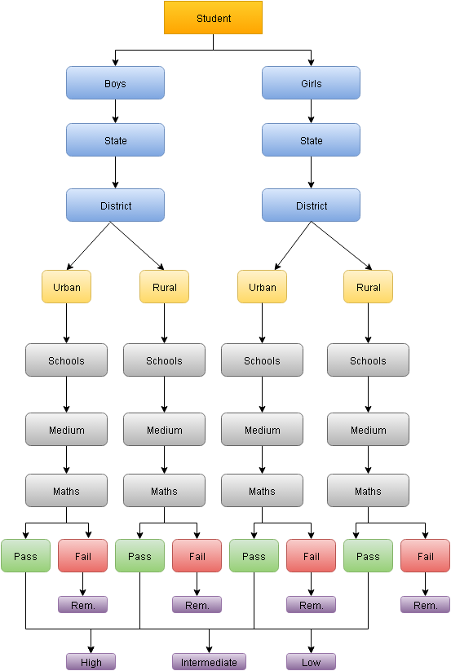

TREE STRUCTURE

